Narimasu Alumni Association
Membership Application Form
New and Renewing Members

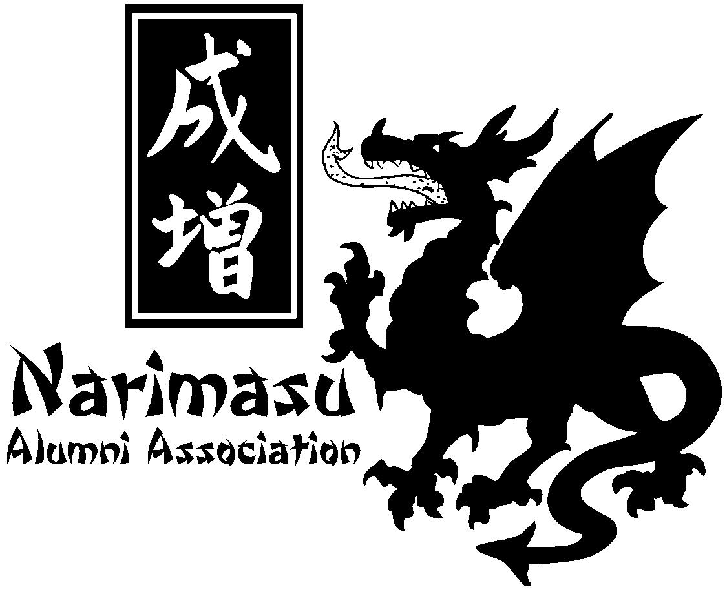
PLEASE fill out and return with payment

Name: _____________________________________________________________________________________________

Address: ____________________________________________________________________________________________

City/State/Zip Code: __________________________________________________________________________________

Home Phone: ________________________________________________________________________________________

Cell Phone: __________________________________________________________________________________________

E-mail address: _______________________________________________________________________________________

Years that you attended Narimasu: ______________________________________________________________________

Year you graduated from high school: ___________________________________________________________________

- Do you want your mailing information made available to the membership? Yes / No (Circle one)

Volunteer Opportunities -- Volunteers are always needed on NAA committees. Please check the committee
opportunities that interest you:

( ) Newsletter – “The Dragons Roar…Again” (This newsletter has been discontinued but will activate again via email)
( ) www.narimasu.org (Narimasu official web site; special members-only, password-protected section)
( ) Alumni Directory – complete directory of all Narimasu attendees –Membership information is being finalized and should be ready by August 2019.
( ) Reunion – held at rotating sites throughout the country
( ) Narimasu Alumni Association Board of Directors Seat Eligibility

PLEASE NOTE: Membership dues have changed

[ ] Annual Dues Amount (January 1 – December 31): $10 Membership is good through December 31 of the year you join or renew.
[ ] Family membership (NHS alum spouses/partners/significant others living in the same household): $15
[ ] Multiple year discount: 3 years for $25.(a $5 savings) $35 for Family

Payment
Please make checks payable to the Narimasu Alumni Association.

Mail your application to: Julie Busching Paige
25889 Road H
Cortez, CO 81321

